**DATA-230 VISUALIZATION PROJECT**

**The Voice of the Developers (AI IN FOCUS):**

**Insights from the 2023 Developer Survey**

**Professor: Dr.Andrew Bond**

**PROJECT BY:  
Name: SHRINIVAS A BHUSANNAVAR**

**Student ID: 016990545**

**GITHUB LINK:** [**https://github.com/Shrini9797/Predictive-Analysis-Visualization-Stack-Overflow-Survey-2023-**](https://github.com/Shrini9797/Predictive-Analysis-Visualization-Stack-Overflow-Survey-2023-)

**REPO NAME: [Predictive-Analysis-Visualization-Stack-Overflow-Survey-2023-](https://github.com/Shrini9797/Predictive-Analysis-Visualization-Stack-Overflow-Survey-2023-)**

**INTRODUCTION:**

For more than ten years, Stack Overflow has been like the hub spot for developers. where they explore, share what they know, and help each other out with problems. So, every year, they do this big survey to figure out what's going on in the world of programming. This time, almost 90,000 developers took part, and it's kind of like getting insights into the stuff in AI.

The 2023 Stack Overflow Developer Survey provides valuable insights into the developer community - their backgrounds, technology use, work environments, and engagement. This annual survey was taken by over 89,000 developers from 185 countries, making it an authoritative voice of developers globally. Understanding who developers are and how they work allows us to better address their needs.

**OBJECTIVE**

In this project, we set out to explore what developers really think about Artificial Intelligence (AI) based on the insights gathered from a survey conducted by Stack Overflow. We wanted to understand the tools and technologies developers commonly use for AI and see how they feel about its accuracy. Our focus was on figuring out if AI has brought about any changes in the way developers work – from coding practices to testing methods. We also wanted to know if developers overall like using AI or if there are some concerns.

Digging deeper, we will look into how developers use AI for learning, coding, and testing, and whether it's making a positive impact on accuracy and productivity. The goal was to find out if AI is really helping developers do their jobs better. Through our analysis, we aimed to provide a simple and clear picture of what developers think about AI, sharing their experiences and insights in a way that's easy to understand. This report aims to shed light on the real-world implications of AI in the developer community and its role in shaping the future of technology.

Top of Form

Bottom of Form

**DATA COLLECTION:**

In this project, we gathered our data from two distinct sources:

**1.Stack Overflow Survey dataset :** [**https://www.kaggle.com/datasets/stackoverflow/stack-overflow-2023-developers-survey**](https://www.kaggle.com/datasets/stackoverflow/stack-overflow-2023-developers-survey)

**2.Global AI Index :** [**https://www.kaggle.com/datasets/katerynameleshenko/ai-index**](https://www.kaggle.com/datasets/katerynameleshenko/ai-index)

The Stack Overflow Survey dataset provides a rich source of information directly from developers worldwide. By tapping into this dataset, we aim to understand developers' perspectives on various aspects, including their use of AI, the tools they employ, and their sentiments towards AI accuracy. This dataset acts as a valuable window into the real-world experiences and opinions of developers across different regions and industries.

Complementing this, I incorporated data from the Kaggle Global AI Index dataset. IT encompasses key information about 62 countries, including the Global AI Index and seven indicators influencing it. These indicators cover Talent, Infrastructure, Operating Environment, Research, Development, Government Strategy, and Commercial aspects, offering insights into AI implementation, innovation, and investment globally.

Together, these datasets serve as the foundation for our analysis, allowing us to draw meaningful conclusions about the current state of AI in the developer community and its broader implications in the global context.

**DATA CLEANING:**

To clean up the data for visualization, I used Python and some features within Tableau. For a clear view, I utilized Python's Pandas library to clean the data and generate total counts for each related column. Chord diagrams were crafted using pivot tables, explode, and group-by functions. Similarly, for other charts like Sankey,

I employed filtering null values and created JSON files for certain D3 plots. The main visualization was done using Tableau supporting the overall presentation.

**DASHBOARD 1:**

**AI In Focus 2023 Survey Insights: Developer Sentiments and Impact**

Gain insights into the genuine sentiments driving the surge in AI popularity this year. Evaluate whether it's genuinely impacting developers' work or if it's more of a hype.

**The dashboard features :**

**Map Chart**: Illustrates survey responses from each country, with the size of each marker indicating the number of respondents. Which provides a global perspective on survey responses, highlighting the distribution of sentiments across different countries.

**Donut Chart :** which offers a detailed breakdown of respondents based on their professional type, work environment, and age group.

**Total respondents based on their development professional type:**

(Outcome: 74% are developers by profession).

**Number of respondents based on their work type (WFH, office, hybrid)**

(Outcome: 66.7% work from hybrid or remote setups, and nearly 14% work solely in person).

**Number of respondents based on their age group** (80% fall within the 18-44 years age bands).

**Bar Chart:** Examines the use of AI tools in the development process. bar chart reveals a significant trend – a majority of respondents either use AI tools in their development process or have plans to integrate them in the near future, indicating a substantial impact of AI in developers' workflows this year.

Yes: 45% No: 27%. No, but plan to soon: 25%

**Summary:**

The survey findings indicate a rising popularity of AI among developers, showcasing its tangible impact on their work. Yet, a worthy number of developers either don't use AI tools or have no immediate plans to do so.

In summary, the survey offers a useful snapshot of the current landscape of AI adoption among developers. It remains intriguing to observe how these trends will unfold in the years ahead.

**Dashboard 2: AI TOOLS SENITMENTS**

It provides an overview of the AI In Focus 2023 survey results on developer sentiments and impact. The dashboard includes several different visualizations, such as maps, charts, and graphs. These visualizations provide insights into how developers are using AI tools, their trust in the accuracy of AI output, and the benefits they are seeing from using AI tools.

**Chart 1: Map Analysis of Respondents' AI Tool Benefits**

Evaluate the perceived benefits of AI tools among respondents, such as speeding up learning, increasing productivity, improving accuracy, and enhancing efficiency. Colors on the map reflect the density of responses, and a filter allows for a country-specific analysis. It shows the percentage of developers in each country who are using or are planning to use AI tools in their development process this year. The biggest benefit that developers see from AI tools is increasing productivity.

**Chart 2: Bubble Chart for AI Sentiments in Software Development**

Explore sentiments towards AI in software development, categorized as favorable, very favorable, unfavorable, and very unfavorable. The chart includes filters for individual countries and developer types (e.g., full-stack, frontend, data scientist).

Country filter : United States of America Country filter : India

**Analysis for Country Filter : United States of America**

The chart shows the sentiment of AI tools among developers in the United States of America, with the size of the bubble representing the number of developers in that category.

Most developers (77%) have a favorable or very favorable sentiment towards AI tools for development. Full-stack developers are more likely to be indifferent than those learning to code (17% vs. 15%).The chart also shows that most developers in the United States are back-end developers, followed by full-stack developers and front-end developers.

Overall, the chart suggests that AI tools for development are well-received by the developer community in the United States. However, there is still some room for improvement, as a significant minority of developers are indifferent or unfavorable towards these tools.

The current chart only shows data for the United States. Added filter to analyze similar data for other countries, to see if there are any regional differences in sentiment towards AI tools for development.

**Chart 3: Radial Chart for Trust and Accuracy in AI**

To Assess the level of trust and accuracy attributed to AI, with categories ranging from somewhat trust to highly trust and somewhat distrust to highly distrust. This radial chart offers a visual representation of respondents' sentiments towards AI reliability.

The radial chart you have provided shows the accuracy of different AI tools within development workflows, as perceived by developers. The chart is divided into four sections, representing fourdifferent levels of trust in the accuracy of the AI output:

* Highly trust: 2.85%
* Somewhat trust: 42.15%
* Neither trust nor distrust: 30.68%
* Somewhat distrust: 21.71%
* Highly distrust: 5.46%
* Overall, developers are somewhat divided on their trust in the accuracy of AI tools. Only a small minority of developers (2.85%) highly trust the accuracy of AI output, while the majority (42.15%) somewhat trust it. A significant number of developers (30.68%) neither trust nor distrust AI tools, while some developers (21.71%) somewhat distrust them, and a small minority (5.46%) highly distrust them.

The dashboard provides a valuable snapshot of the current state of AI adoption in the development community. It can be used by developers to learn more about how their peers are using AI tools, and to identify potential benefits of using AI tools in their own development process.

**Dashboard 3: AI TOOLS NEXT YEAR**

The dashboard is designed to show how developers of all experience levels are anticipating changes to their workflows due to AI tools. The graph shows that the four most important tasks for developers are writing code, debugging, and getting help, project planning, and documenting code.

**Stacked Bar chart: ( Ai Tools for Next Year Expectations):**

The graph illustrates the percentage of interest in various activities related to software development, including writing code, project planning, learning about a codebase, documenting code, deployment, and monitoring, collaborating with teammates, and testing code.

1. **Popular Activities:** Writing code is the most popular activity, with 51.20% interest, followed by testing code (41.51%) and debugging/getting help (44.99%).
2. **Specialization Trend:** Interest decreases for more specialized activities; for example, more people are interested in writing code (51.20%) than in learning about a codebase (47.00%), suggesting a preference for getting started in software development rather than specializing.
3. **Collaboration Insight:** The interest in collaborating with teammates is relatively low at 30.10%, indicating that many developers may work independently or have limited collaboration with teammates.

Overall, the graph provides valuable insights into the diverse interests of software developers. It suggests potential areas for educational resources, tools, and communities to support their needs.

**Bar Chart: AI Usage in Development Workflow**

For Filter: **Currently using**

The bar chart shows how important AI is for different tasks in the development process, depending on the AI tool being used. AI is most helpful for fixing issues and seeking help (49.99%), learning about a codebase (47.00%), and testing code (41.51%). On the other hand, it's less crucial for writing code (37.99%), planning projects (33.79%), handling deployment and monitoring (33.79%), and working with teammates (30.10%).

Summary:

1. **AI in Focus Areas:** AI is super useful for fixing issues, understanding code, and testing. It makes developers more efficient in these tasks.
2. **Mixed Importance:** For writing code, planning projects, deploying, and teamwork, AI is not as crucial. It might not be as effective in these areas or isn't used widely yet.
3. **Tool Matters:** The specific AI tool used plays a big role. The chart shows that the current AI tool is more helpful for fixing issues than other tasks.
4. **In a nutshell, the chart suggests that AI is becoming more important in development, making certain tasks easier. However, there's still room to improve in some area.**Top of FormBottom of Form

**Chord diagram: AI Search Tools**

Developers like trying out new technologies. We're checking which ones they're interested in based on what they use now. I created a chord diagram using D3, allowing data filtering, and performed pivot calculations in Python to analyze the AI search tools preferred by developers.

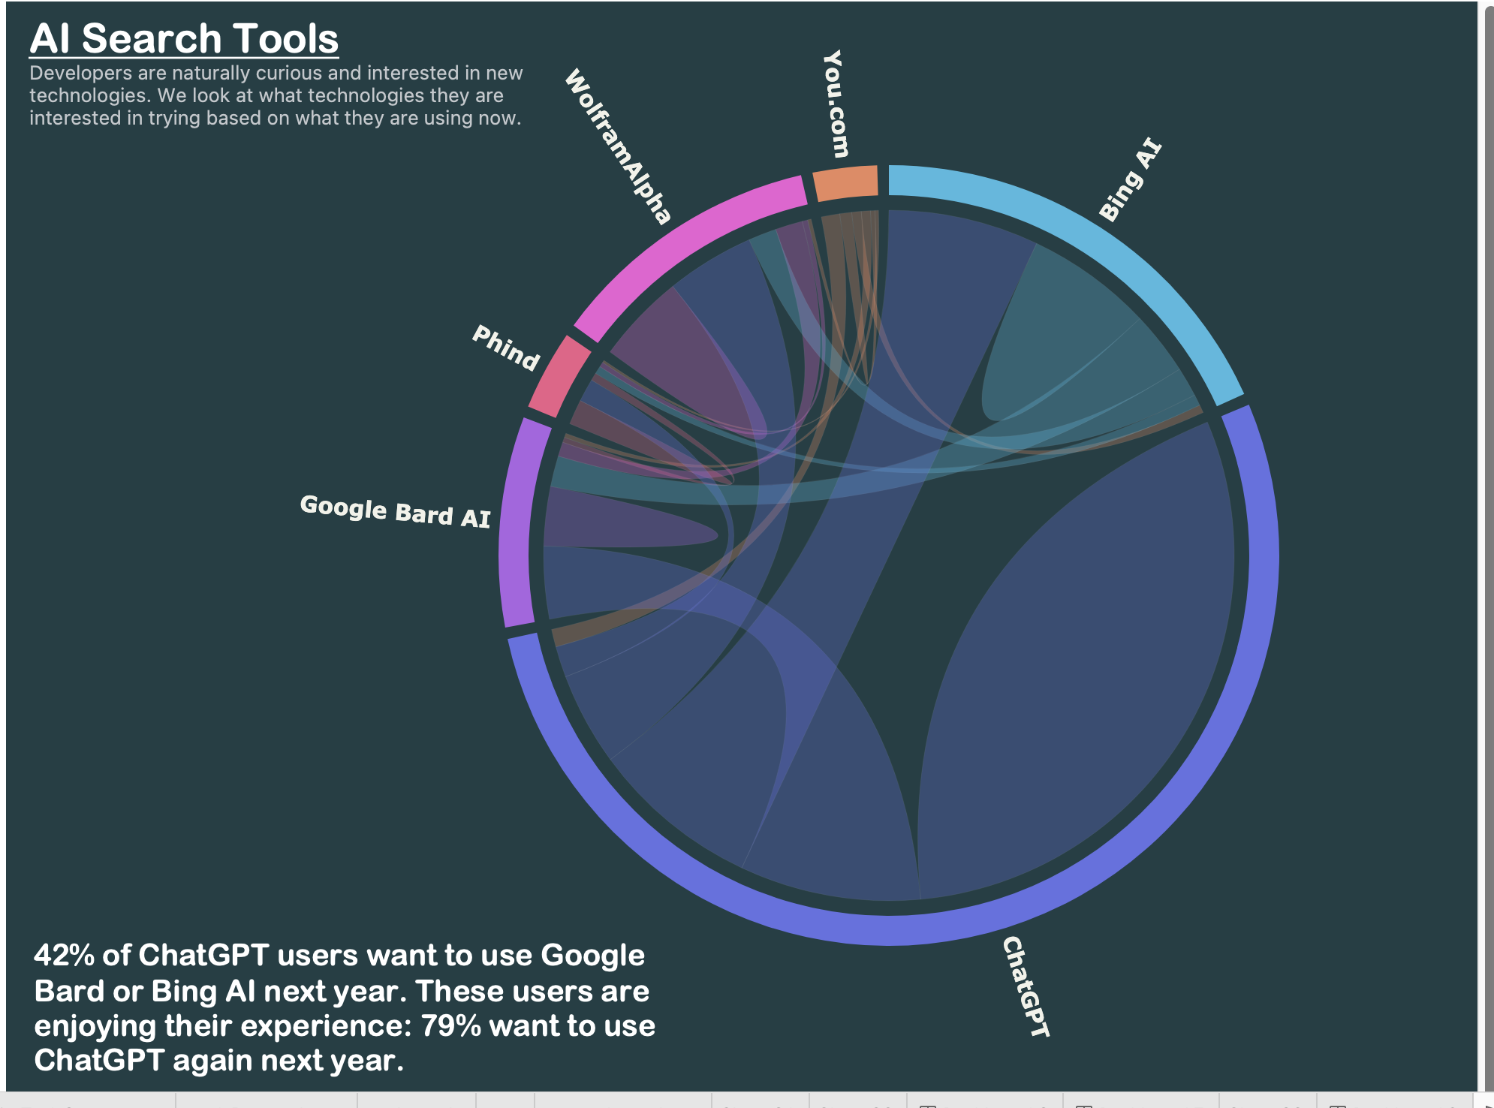

The chord diagram shows the percentage of chatbot users who want to use Google Bard or Bing at next year. The percentage of chatbot users who want to use Google Bard or Bing at next year is based on the number of chatbot users who are currently using each platform.

The diagram shows that **42% of ChatGPT** users want to use **Google Bard** or Bing at next year. This is the highest percentage of users from any platform.

It says that "10,833 who worked with ChatGPT want to work with Bing AI" means that out of 10,833 people who worked with ChatGPT, a significant number of them expressed interest in working with Bing AI.

It says that "9,616 who worked with Bing want to work with ChatGPT" means that out of 9,616 people who worked with Bing, a smaller number of them expressed interest in working with ChatGPT.

The difference between the two numbers (10,833 - 9,616 = 1,217) suggests that there is a greater interest in working with Bing AI than there is in working with ChatGPT.

The diagram also shows that 30% of You.com users and 25% of WolframAlpha users want to use Google Bard or Bing at next year. This suggests that these users are looking for a more comprehensive chatbot experience than what is currently offered by You.com and WolframAlpha.

The diagram also shows that 20% of Phind users and 15% of Bing AI users want to use Google Bard or Bing at next year. This suggests that these users are not entirely satisfied with the chatbot experience they are having on Phind and Bing AI.

**Sankey chart: with filter on (AI DEV Tool) :**

**Fig:1 Fig:2**

The Sankey chart illustrates how users transition between different AI developer tools. GitHub Copilot leads as the most favored tool, with 50.2% of users, followed by Tabnine (25.1%) and Whispr AI (12.4%). AWS CodeWhisperer (12.3%).

Key Insights:

1. **GitHub Copilot Dominance:** GitHub Copilot is the top choice, likely due to its integration with GitHub, the widely used code hosting platform.
2. **Switching Trends:** A notable percentage of users switch between AI developer tools. For instance, 20.1% of GitHub Copilot users try Tabnine, and 15.6% of Tabnine users explore GitHub Copilot, indicating an ongoing exploration of tools to find the best fit.
3. **Tabnine as an Alternative:** Tabnine emerges as a popular alternative to GitHub Copilot. Notably, GitHub acquired Tabnine in 2022, suggesting potential future integration.
4. **Less Popular Tools:** AWS CodeWhisperer and Visual Studio IntelliCode have lower popularity, possibly due to being newer or less integrated with popular code editors and IDEs.

**Fig:2 Results**

Results show that 26% of users want to work with Tabnine, while 100% of users want to work with GitHub Copilot.

This suggests that Tabnine is a popular alternative to GitHub Copilot, but that GitHub Copilot is still the preferred tool among AI developer tool users.

**Zoomable Bubble Chart: Developer Tools Overview**

**Five main categories:**

**1.LANGUAGES**

**2.WEBFRAMEWORKS**

**3.NEWCOLLAB TOOLS**

**4.DATABASES**

**5.OFFICE TOOLS**

This interactive chart allows users to zoom in and explore details within each category, providing a visual and user-friendly representation of various developer tools across these five significant domains.

**POPULAR LANGUAGES: POPULAR DATABASES:**

**POPULAR COLLAB TOOLS: POPULAR WEBFRAMWORKS:**

From the zoomable bubble chart, the major tools in each category are:

1. **Languages: JavaScript**
2. **Web Frameworks: ReactJS**
3. **New Collaboration Tools: VS Code**
4. **Databases: PostgreSQL**
5. **Office Tools: Jira**

These tools stand out as significant choices in their respective categories, as highlighted in the bubble chart.

**GLOBAL AI INDEX DASHBOARD:**

**The dashboard you sent shows India's performance on the Global AI Index 2023. The index measures the performance of countries in terms of their AI innovation, investment, and implementation.**

In the Global AI Dashboard,with three bar charts provide insights into innovation, implementation, and investment across various countries.

The data reveals that the USA is a leader, topping the charts in almost all categories. Surprisingly, India does not rank within the top 5 countries in these aspects.

This suggests a notable discrepancy in the AI landscape, emphasizing the dominance of the USA in AI-related innovation, implementation, and investment compared to other countries, including India**.**

Bar chart Tree map

**Insights from dashboard:**

1. **Global AI Leadership:**

The United States maintains its position as the world leader in AI.

China is swiftly advancing and narrowing the gap in AI capabilities.

1. **Leading AI Hubs:**

Beyond the U.S. and China, other prominent AI hubs include Israel, Singapore, and the United Kingdom

The treemap shows the distribution of software development tasks across different stages of the development lifecycle. The size of each rectangle represents the percentage of time that developers spend on that task.

The treemap shows that the majority of time is spent on coding (35.2%), followed by testing (28.1%), and debugging (18.4%). Documentation and deployment are the least time-consuming tasks, at 7.8% and 10.5%, respectively.

**INSIGHTS FOR INDIA:**

* Education & Training: Investing in AI skills development will create a workforce capable of supporting AI development and deployment.
* Infrastructure: Development of data centers, cloud platforms, and telecommunications networks will provide the foundation for AI solutions.
* Government Support: Increased support through financial incentives, tax breaks, and assistance for AI startups will further accelerate the adoption of AI.

**Summary:**

In summary, our exploration into the world of AI covered a wide range of areas, from how developers feel about it to its global reach and the tools they use. Here's what we learned:

1. **Developers and AI:**
   * Developers are keenly interested in AI, seeing it as a valuable part of their work.
   * Activities like debugging, learning about code, and testing are where AI shines for developers.
2. **AI Around the World:**
   * The global scene shows a surge in AI use, with the United States leading the pack, followed closely by China, Israel, Singapore, and the United Kingdom.
   * India is on the rise, marking a significant jump in the Global AI Index from 2021 to 2023.
3. **Favorite Tools:**
   * GitHub Copilot steals the show as the go-to AI tool for developers, with a lot of them switching between different tools.
   * Popular languages like JavaScript, frameworks like ReactJS, and collaboration tools like VS Code are hot topics for developers.
4. **Making AI Work:**
   * AI's importance varies across tasks, with GitHub Copilot shining in debugging and seeking help.
   * Developers are still exploring AI tools, trying to find the perfect fit for their needs.
5. **India's Approach:**
   * In India, the strategy for AI centers on education, infrastructure, and government support to create a favorable environment.

**Conclusion:**

In conclusion, our findings reveal a dynamic AI landscape. While the United States stays on top, other countries like China and India are catching up. Developers are actively embracing AI tools, indicating a significant shift in how technology is used. Looking ahead, innovation, investments, and skill development will continue to shape the future of AI, influencing technology landscapes across the globe.

Top of Form

Bottom of Form